- Purpose

The purpose of this policy is to introduce new full-time employees to Giles Chemical’s policy regarding when and where safety glasses and safety shoes are to be worn and reimbursement for such.

- Scope

All Giles employees will be required to wear safety shoes when working in production areas.
Safety shoes shall comply with ANSI Z41.1 and ASTM F2413-05 safety standards. (Steel-toed or composite work boots or shoes)

- Responsibility

Safety Department is responsible for overseeing this program.

All employees are responsible for turning in their receipt to the Safety Department in a timely manner.

- Safety Considerations

Safety glasses and appropriate safety apparel are to be worn at all times.

Safety is a condition of employment. Employees are not authorized to work in an unsafe manner and are prohibited from harming the environment of the facility or community.

- Materials/Equipment-

N/A

- Policy:

- Safety Shoes

All Giles employees will be required to wear safety shoes (steel-toed or composite work boots or shoes) when working in the production areas (main plant, repack and warehouses). Administrative employees are also required to wear safety shoes when working in the production areas. Safety shoes shall comply with ANSI Z41.1 and ASTM F2413-05 safety standards. Safety shoes are not required in designated safety areas by employees or visitors (see attached diagram).

Giles will reimburse employees for one pair of safety shoes every calendar year up to fifty dollars ($50) or twenty-five dollars ($25) twice a year. Upon submission of the receipt to the Quality/Safety Department, the receipt will be processed for reimbursement of funds to the employee. Receipts must be at least six months from previous receipts. The payables process will generally take a week to ten days.

- Safety Glasses

All Giles Chemical employees will be issued a pair of safety glasses to be worn at all times in the production areas (main plant, repack and warehouses). Replacement of non-prescription safety glasses may be obtained from the Quality/Safety Department.

An employee who requires prescription safety glasses will be allotted $225.00 every two years. The Quality/Safety Department will provide these employees with a voucher for the purchase of prescription safety glasses through Wal-mart Vision Center. Glasses are to be chosen from styles available through a contract with this vendor. If an employee needs special glasses outside of the contract, it must be approved by the Quality/Safety Department. Giles Chemical will reimburse employees who choose to buy glasses through a vision center of their choice. Employees will be responsible for payment for their own eye exams.

- Designated Safety Areas

There are designated safe areas in the main plant production area. These areas are demarcated by signs and/or physical barriers and outlined as such by the attached
"Designated Safety Area" diagram. Safety glasses must be worn in these areas but safety shoes may or may not be a requirement.

Any and all persons not employed by Giles but entering the facility will be expected to follow the safety guidelines outlined by Giles.
Visitors must be met by their contact at Giles and accompanied to their designation donning the appropriate personal protection equipment (safety glasses, safety shoes, etc.) and visitor badge. Please ensure that safety glasses and visitor badges are returned to the front office and that the visitor signs out.
Contractors will be given a brief safety orientation before they will be allowed to perform their duties. Contractors are responsible for providing their own personal protection equipment.
Truck drivers will be expected to follow the safety guidelines outlined by Giles. Truck drivers will only be permitted in designated areas and are not allowed to venture through the plant.

MAIN PLANT SAFETY DIAGRAM

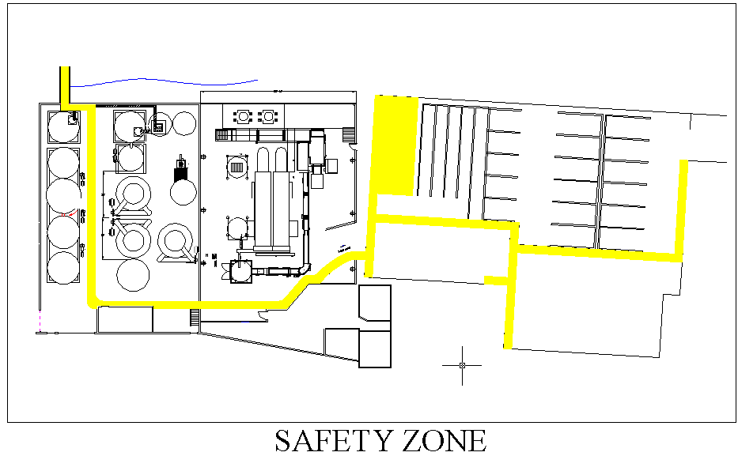

- Reference Documents

N/A

- Change Information

Document review- updated format using new template and numbering system.

